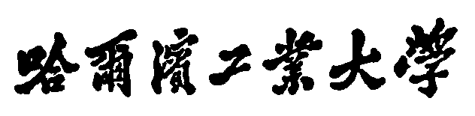

Technical Report

Student Name： 袁琪博 Student ID： 120L022116

Student Name： 李世轩 Student ID： 120L022109

Student Name： 赵雨田 Student ID： 120L022111

# 1.New Features

1.1 Add an menu for select different levels.

1.2 Three levels of difficulty and an endless mode.

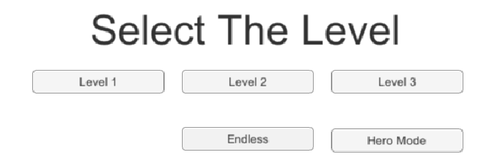

1.3 Add background music and sound effect.

1.4 Add scores system. When the character touches a star, the score is increased by ten.

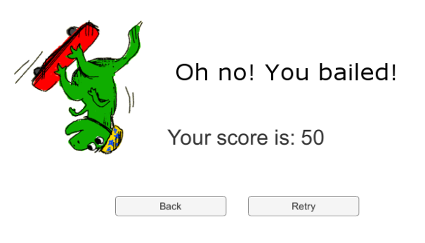

1.5 A special mode with new character.

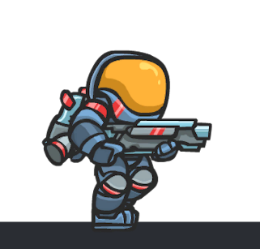

1.6 Add another gameplay which removes the gravity property on top of the existing gameplay. Players can activate this feature by touching a specific item called wing at the beginning of the game.



1.7 Replace Application.LoadLevel() to use newer SceneManager SceneManager. LoadScene().

1.8 Add some new prefabs.

1.9 Add a cheat key. Players can press “H” key to add 100 hearts.

1.10 Add player animation. When you select Hero Mode, you can see the animation.

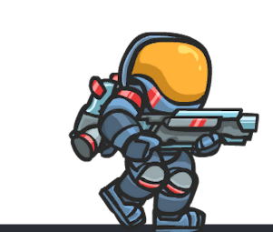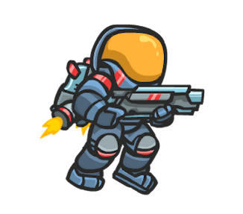

# 2.Encountered difficulties and solutions

2.1 Add suitable music to the game.

The way to add music is simple, but how to add the suitable music is difficult. Because the music needs to match the plot, atmosphere, and player's experience of the game. To add the suitable music, we searched for lots of music from <https://www.aigei.com/music/game/>and<https://www.bjxku.com/resources/music/777-7-632/>. Finally, we selected four suitable music.

2.2 Add the property which can make the character fly.

First of all, decreasing gravity to zero keep the subject suspending. To make the game playable, the key “down” will apply a opposite force. Strangely, doing this will stop the subject, instead of keep moving at a certain speed.

In the manual, I find such explanation: “Because this function has different modes, the physics system only accumulates the resulting velocity change, not the passed force values.”

Another problem is the subject will fly out of the screen. I just add a cube a little above the screen.

2.3 Add a special mode with new character.

To keep the UI and sound effect, the controller class of new character is inherited from the original one. We add animator controllers and delete the limitition to the jump since he has a jetpack.

2.4 Add endless mode.

When we add the endless mode, we ran into trouble. But after looking up the information, we finally successfully completed the function with the cooperation of our team members.

# 3.Group division of labor

袁琪博：1.1 1.2 1.3 1.4 1.5 1.7

李世轩：1.1 1.2 1.4 1.5

赵雨田：1.2 1.4 1.5 1.6 1.8 1.9 1.10